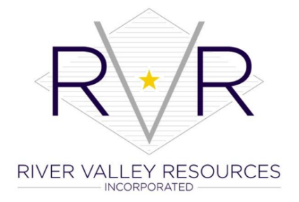

FOR IMMEDIATE RELEASE

Contact:
Konnie McCollum
River Valley Resources, Inc
(812) 265-2652
info@rivervalleyresources.com

Madison business recognized during Adult Education Day at the State Capital

River Valley Resources’ student wins State Essay Contest

Madison, IN – January 31, 2021 – On January 24, 2022, Adult Education Day at the Statehouse celebrated the accomplishments of adult educators across the state, business partners and adult education student essay contest winners. Madison Precision Products (MPP) was one of the businesses recognized for its partnership with River Valley Resources (RVR) Adult Education, and RVR student Alice Kerrigan won the state essay contest.

Adult Education Day at the Statehouse, sponsored by the Indiana Association of Adult and Continuing Education IAACE), included a Proclamation from Indiana Governor Holcomb and celebrated the accomplishments of adult educators across the state. Indiana is a national leader in adult education, and for the past several years has finished in 1st place for learner achievement, or measurable educational skills gains. Indiana has also placed 3rd in high school equivalencies and 7th in specialized Integrated Education and Training (IET) programs.

Madison Precision Products was among the businesses recognized at the event for community partnerships. MPP and RVR adult education have two workplace education partnerships; the longest running program helps employees prepare for the leadership assessment for possible promotions, and the second program is a conversational English class for Japanese associates who are working at MPP. RVR has been in partnership with MPP for 4 years through adult education and much longer through the larger workforce development organization.
MPP spokesperson Nancy Sobeck, who accepted the award on behalf of the Madison company, said “The company supports education at every level in our community. MPP recognizes education as a key to success.”
RVR Executive Director Margo Olson said, “We sincerely appreciate our long-standing, valuable partnership with MPP as well as their significant contribution to our community.”
Alice Kerrigan, an RVR adult education student, won the state essay contest. Unfortunately, Kerrigan was hospitalized on the day of the ceremony, so RVR Adult Ed staff read her essay for her while she watched via Messenger from her hospital bed.
“We are absolutely proud of Alice for her motivational and inspirational essay, and we wish her the speediest of recoveries,” said RVR Adult Education Director Konnie McCollum.
Also among businesses honored at the event was local company Dave O’Mara Contractors for their construction education partnership with Jennings County Adult Education.
RVR Adult Education provides free adult education services to 12 Indiana counties. Those services include high school equivalency classes, occupational skills training, apprenticeship opportunities, workforce education programs, English language learning, military preparation and college preparation.

###

